EARPLUGS
Silicon protection earplugs to be used for aviation,
swimming, sleep, industrial noise environment.
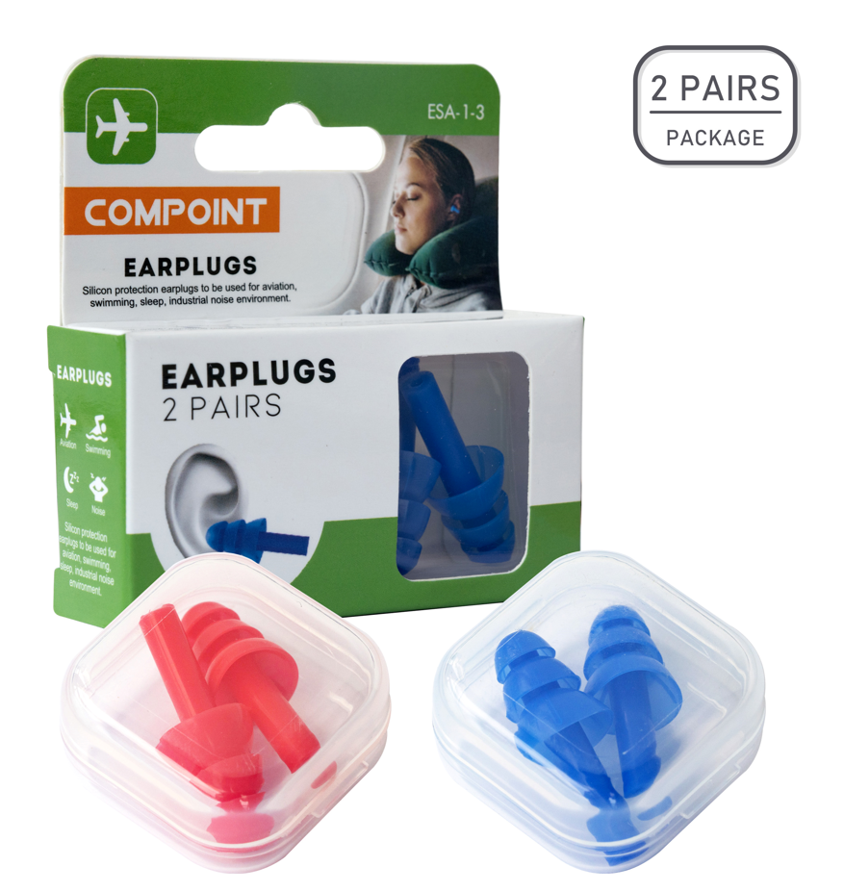
Air flights pressure comfort protection to sinus and eardrums - The earplugs soft silicon designed to modularize itself into the ear to provide a firm fit to effectively reduce air pressure in high climbing or dropping thus can offer some comfort protection to sinus and eardrums during flight.

FEATURES
- Silicon earplugs to be used for aviation, swimming, sleep, industrial noise environment.
- Air flights pressure comfort protection to sinus and eardrums - The earplugs soft silicon designed to modularize itself into the ear to provide a firm fit to effectively reduce air pressure in high climbing or dropping thus can offer some comfort protection to sinus and eardrums during flight.
- Noise Protection - The earbuds are designed to provide noise reduction protect your hearing from anyone with harmful noise and high pitch levels.
- Designed - Shaped to provide low pressure on the ear canal, and is suitable for different ears, so the earplugs can adapt to different ear sizes, thereby ensuring effective noise reduction.
- Suitable for long-term wear.
- Easy to take out, wash with regular soap and water , put back into the box and ready to use for the next flight.

